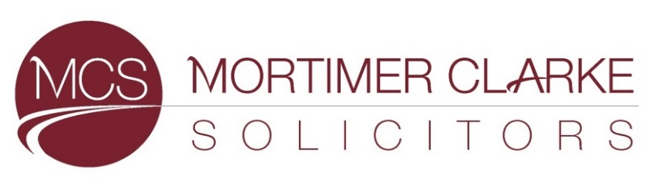

Fixed Fee Debt Recovery
We are required by the SRA Transparency Rules require us to publish on our website certain costs information in relation to debt recovery work.
If you wish to instruct Mortimer Clarke Solicitors in relation to debt recovery litigation, then please contact Sandra Bayne (sandra.bayne@mortimerclarke.co.uk)
We have set out below details of court disbursements and solicitors’ fixed costs during the period up to and including judgment. We may charge additional fees or adopt a different fee structure depending on the value and complexity of your instructions, and on the volume of work you wish to instruct us on. We would discuss this with you once you have provided us with details of any instructions.

These costs apply where a claim is in relation to an unpaid debt which is not disputed and enforcement action is not needed.

If at any stage the other party disputes your claim, we will discuss any further work required and provide you with revised advice about costs if necessary, which could be on a fixed fee or based on an hourly rate.

Claim amount | CCBC fee
Up to £300 | £25
£300.01 to £500 | £35
£500.01 to £1,000 | £60
£1,000.01 to £1,500 | £70
£1,500.01 to £3,000 | £105
£3,000.01 to £5,000 | £185
£5,000.01 to £10,000 | £410
£10,000.01 to £100,000 | 4.5% of the claim

FIXED SOLICITORS COSTS ON ISSUE OF CLAIM
Claim amount | Fixed solicitors’ costs
£25 to £500 | £50
£500 to £1,000 | £70
£1,000 to £5,000 | £80
Over £5,000 | £100

FIXED SOLICITORS COSTS ON ENTRY OF JUDGMENT
Claim amount | Fixed solicitors’ costs
£25 to £5000 | £22
Over £5,000 | £30

Anyone wishing to proceed with a claim should note that:

- The VAT element of our fee cannot be reclaimed from your debtor.
- Interest may take the debt into a higher banding, with a higher cost.
- The costs quoted above are not for matters where enforcement action is taken in order to recover your debt. There are further court fees and solicitors’ fixed costs relating to enforcement action.

Our fees includes:
- Taking your instructions and reviewing documentation
- Sending a Letter before Claim
- Receiving payment and sending onto you, or if the debt is not paid, drafting and issuing a County court claim
- Where no Acknowledgment of Service or Defence is received, applying to the court to enter Judgment in default
- When Judgment in default in received, writing to the other side to request payment
- If payment is not received within an agreed period of time, providing you with advice on next steps and likely costs

We will usually issue a claim 33 days after sending a Letter Before Claim. If the other side does not respond to the court proceedings, judgment in default can be requested approximately 15 days after the claim has been served. We will then ask the other side to make payment. If enforcement action is needed, the matter will take longer to resolve.

